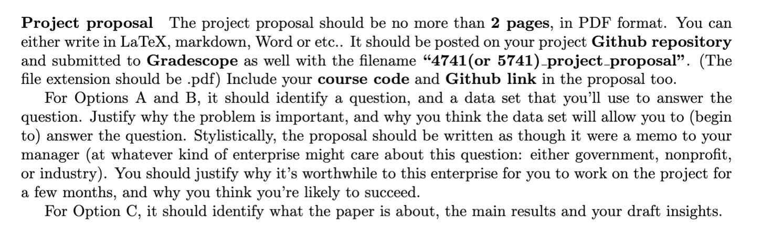

Earthquake Data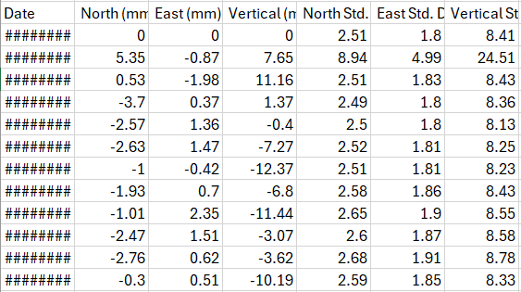

Displacements:

Locations, Magnitudes, etc. (NEIC and ISC databases):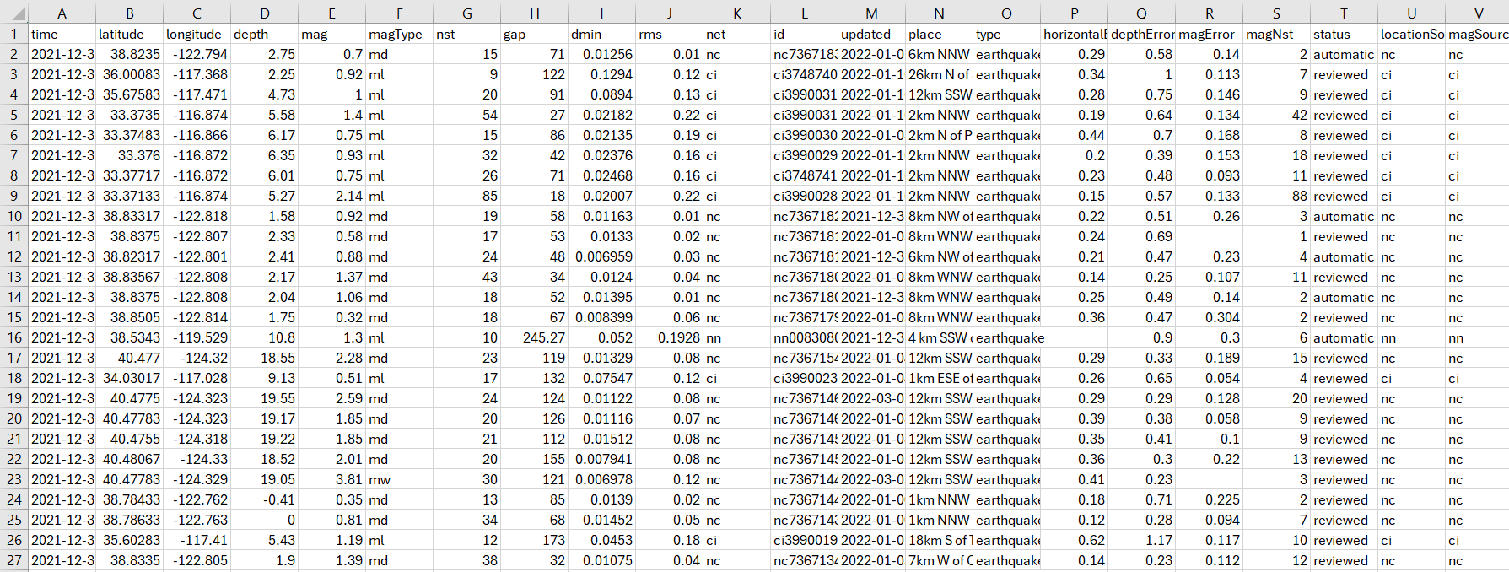

NFL Play Data (NFLsavant)

There are other sports datasets here: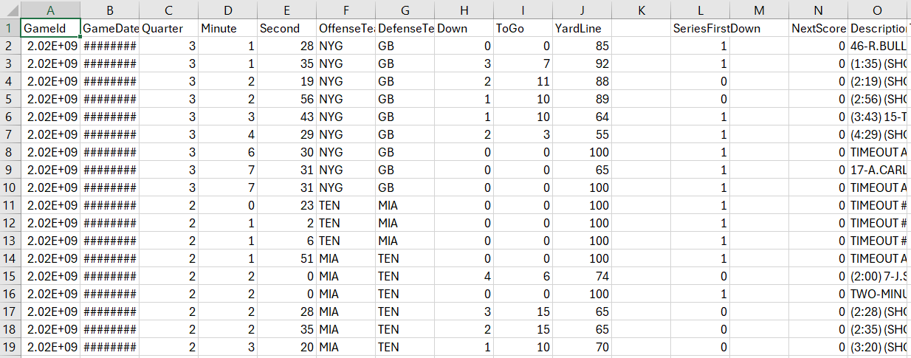

<https://sportsandsociety.osu.edu/sports-data-sets>

<https://archive.ics.uci.edu/dataset/158/poker+hand>

<https://archive.ics.uci.edu/dataset/186/wine+quality>

<https://www.isc.ac.uk/iscbulletin/search/catalogue/>

<https://earthquake.usgs.gov/earthquakes/search/>